Real Estate Advertisement

# Jacquelin Jimenez

## CIS 162 02

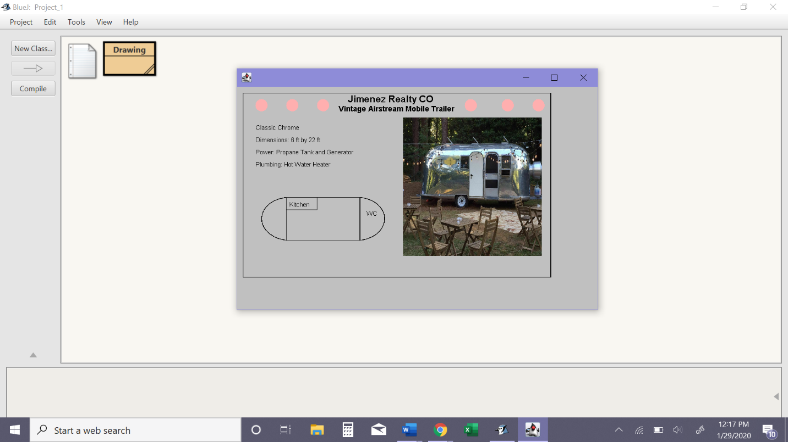

I pledge that this work is entirely mine, and mine alone (except for any code provided by my instructor). I received help from my instructor, Ana Posada. I also used the Java API.

I spent around 5 hours total on this project. I started on January 25th by reading the project document fully. I had an idea of what I wanted to “sell” so I started by researching information and pictures of a chrome trailer. From January 25th to January 29th I modified the provided code and added my own new code to the project. I also troubleshot errors that arose by reading the zybook and looking over past in class labs. On January 29th I finished my project and the challenge requirements.